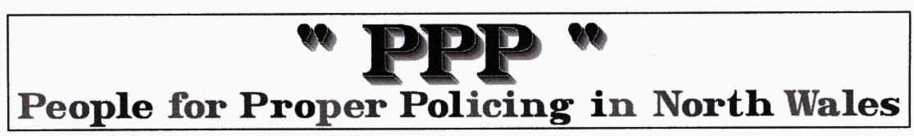
What are some of Police officers doing?… REAL COMMUNITY POLICING

Old Colwyn (East) Residents’ Association www.oldcolwyneast.co.uk
Minutes of the Open Meeting Wednesday 11th August 2010

Item 6 Local Police Report
PCSO Martyn Lewis was present and gave the following report.
Reference the antisocial behaviour, we have two problem groups and they are known. With regards to the problems two weeks ago, the Sergeant and Inspector have organised extra foot patrols to combat the problem, We are still taking alcohol off these people and asking people to ring the information in. The police know where they go to drink.
Surgeries are being held at the Bay View Centre and people are talking to the officers. Please phone up using the 101 number.
The Balance your Bobbies Initiative is still running and people change their priorities every month, which is understood.
Worryingly there has been a slight increase in burglaries, we have arrested four people and since they have been in custody they have ceased.
People are making things easy for these people leaving windows and doors open and unlocked. People get complacent. Please be vigilant locking everywhere up. Where incidents happen we are target hardening the premises. The Folly was mentioned earlier and locks and bolts have been fitted so persons cannot access the sheds.
Local youths in Min y Don Park are playing in a football tournament. A resident has given her time freely. Twenty to thirty lads are involved and it is a very good thing to keep them involved.
A resident reported that the previous Friday she had left her car boot open whilst ferrying shopping bags to her house and she saw two lads with hoodies on and one had picked up a bag from her car. He dropped it again when she called and said that they were looking for a football. Just to warn others of what happened.
Martyn replied that he had done two visits today and at one of them, the garage doors and three windows were open with nobody in the premises.
Councillor Bob Squire added, to reinforce the message, he had brought it up with David Jones MP that people were moving to Colwyn from Rhyl because of the demolition that is going on there. Some are not decent people, the police are aware of it and he has seen the list of the people concerned and where they are living. It is mainly in Colwyn Bay but they move house quickly. He continued that he ties a lot of the problems in with the Transient population who are moving in from Rhyl, Manchester and Liverpool.
There should be a lot more keeping of figures as to the demographics and the background of these people.
Under a Freedom of Information request, it was discovered that three quarters of the persons committing offences in Conwy were from outside North Wales.
The secretary commented to Martyn that it has been noted by several persons that he had spoken to that there have been a lot more police patrols around. So it is noted and greatly appreciated and that message should go back to the Inspector and Sergeant.
Martyn replied that they had run an operation for two weeks and there is an intention to keep it running. Martyn was thanked for his report by the Chair.

The PPP comments … This article covers so many issues from our 7 yr campaign that we had to publish it. Decent people are at last working with available local police to deal with the issues that blight their community. Surgeries and balance your bobbies work BUT are relics of the past regime which was a gimmick a day many without substance. Just meeting with, visiting and being available on the street or in the local police station and via 101 is all they need. If the population is 2000- the police have potentially 2000 pairs of eyes and ears! Despite statements by Kenneth Clarke about releasing criminals back on the street the comment about captive burglars says it all!. If Clarke made prison less attractive they might think twice about risking it. The destructive policy of moving dysfunctional families and individuals into decent areas is a political policy from the past regime and David Jones via May & Clarke is responsible for stopping it ASAP. Another past control freak policy, CCTV, created the hoodie culture and cost a fortune for little effect. We still don’t support the policy that created PCSOs BUT we commend Old Colwyn’s PCSO and hope he applies for the CBMs job.

We are concerned when we often read that the patrols, etc, will continue for 2 weeks and then …what will our Police officers be doing again? … if you get the point. Community Policing must be continuous but random, INTELLIGENCE BASED and moving towards ZERO tolerance.

We REPEAT, yet again, crime prevention does not generate paperwork of fill prison cells or traumatise vulnerable citizens.

We REPEAT yet again, all any police officer of any rank needs to do his job is to read, understand and abide by the 1829 guidelines … here …
www.properpolicing.org.uk/articles/The%20Nine%20Principles%20of%20Policing.pdf

